|  |
| --- |
|  |

|  |
| --- |
| PROPOSAL |
| Past & Present | |
| Thailand | |

|  |  |  |
| --- | --- | --- |
| Quotation for |  | SENSES |
| Duration |  | 13 Days |
| Travel Period |  | N/A |
| Destinations |  | Thailand |
| Tour Type |  | N/A |
| Reference no. |  | N/A |

Itinerary

|  |  |  |
| --- | --- | --- |
| Day 1 | Bangkok | (B,L,D) |

**Breakfast in hotel**

Discover the local places in Bangkok

Tour today is all about the combination of Thai and Chinese culture in Bangkok. You will see the diversity of culture in this society.

The first destination for today is **Wat Trimitr**, which houses the world's largest massive gold seated Buddha measuring nearly five meters in height and weighing five and a half tons. In the past, artisans crafted the Buddhas in gold and disguised them from invading armies by a covering of stucco and plaster. It was discovered by accident when it was accidentally dropped as it was being moved, revealing, under a casing of plaster, a beautiful solid gold Sukhothai style Buddha. Pieces of the plaster are still kept on display.

The next on is also one of the most popular Thailand’s destination. It’s called “**Yaowarat**”, which is packed with market stalls, street-side restaurants and a dense concentration of gold shops. Chinatown is an experience not to miss. The energy that oozes from its endless rows of wooden shop-houses is plain contangious – it will keep you wanting to come back for more.

After that, we will take you to **Wat Mangkon Kamalawat**. The temple is also popular called Wat Leng Noei Yi, which means the temple of the Dragon Lotus in Chinese dialect, and is built in southern Chinese architectural style which takes red as the main theme color. You can see a beautiful dragon and lotus mural artworks at the temple as well as Chinese-style Buddha images enshrined in the main hall.

**Por Tek Tung Foundation**, where you can learn and experience the belief of the Chinese that people should help each other and that the reason, why this foundation was found.

**Lunch** at the local restaurant.

After a walk through a few attractions, we will take **Tuk Tuk Tour**, which will take you to gather up the view of many important and popular tourist attractions in Bangkok.

On this tour, you will travel by The Tuk Tuk and will drive pass **The Wat Suthat**. It is one of the most important and one of the oldest temples of the Rattanakosin era in Bangkok. At the same time, you will see the **Giant Swing,** which was nominated as a future UNESCO World Heritage Site. The next attraction of this tour is **Tiger God Shrine**, which is a very popular merit making place among the old Chinese community. Then we will drive pass **Sanam Luang** and **Tha Pra Athit**. After that you will drive pass another important Temple in Bangkok**, Wat Bowonniwet Vihara**. Then the Tuk Tuk tour will end up at **Loha Prasat**, which means iron castle or iron monastery. It’s the only one of its kind in existence today, it is under consideration with UNESCO to be made a World Heritage Site.

The last destination and the high-light for today is **Wat Saket,** the temple of the Golden Mount in sight. On the way to top of the Golden Mount, there are many bells to hit. We believe that the sound of hitting bells will go to heaven. It is a sign to show that we do goods. On the top of the Golden Mount you will have a chance to relax with a panoramic view of Bangkok City.

After a long day we will go to **Pad Thai Thip Samai** or Pad Thai Pratu Pi, one of the most famous Pad Thai restaurants in Bangkok, where your stomach will be filled up after one day Tour through Bangkok City.

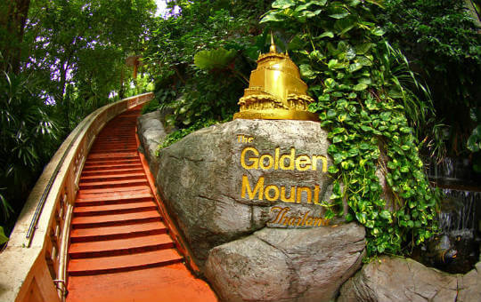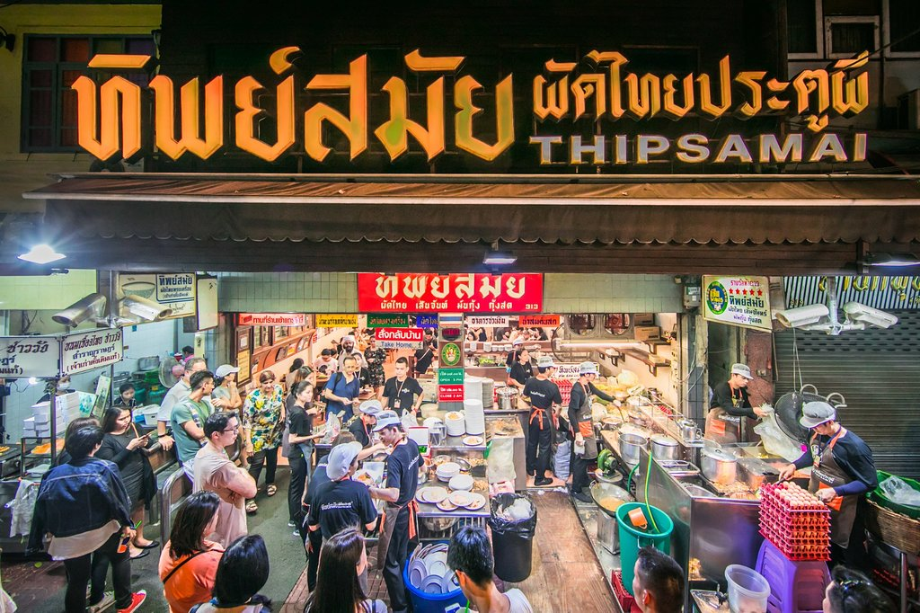

**Overnight in Bangkok**

|  |  |  |
| --- | --- | --- |
| Day 2 | Bangkok | (B,L,-) |

**Breakfast in hotel**

**The middle voice**

Today, we will visit the **National Museum**, where you can learn and see the largest collection of Thai art and artifacts in the country.

**Klong Tour**

After the museum we will go to the pier and take the longtail boat to go to **Khlong Bang Luang Artist Village**, The centrepiece of the Khlong Bang Luang community is Baan Sinlapin (Artists House), which occupies a century-old two-storey teak wood house set beside the canal and clustered around a 300-plus-year-old chedi. A relic of the Ayutthaya period that rises from Baan Sinlapan’s open-air belly, locals still place offerings before the chedi each day. Baan Sinlapin came into existence just three years ago when prominent Bangkok-based artist and conservationist Chumphon Akhpantanond set out to turn the dilapidated but charming old structure into an artist-run cafe and performance space. Everyone from notable professional artists to teenage art students joined the handful of creative types who already lived in the neighbourhood to rally around Chumphon and transform the space into a unique centre for the arts. After finishing at Khong Bang Luang, we will take you to **Wat Arun**

**(The Temple of Dawn):** You'll stop at the dazzling Temple of Dawn (Wat Arun) along the way. This is the most well-known landmark and photographed image of Bangkok. It over 70 metres high, the spire is beautifully decorated with tiny pieces of coloured glass and Chinese porcelain placed delicately into intricate patterns. The smaller towers are equally beautifully adorned with ceramics that sparkle in the sun. Although, it is known as the Temple of the Dawn, it is absolutely stunning at sunset. For enjoying the sunset, we can go to have a drink at rooftop bar at the opposite side of Wat Arun.

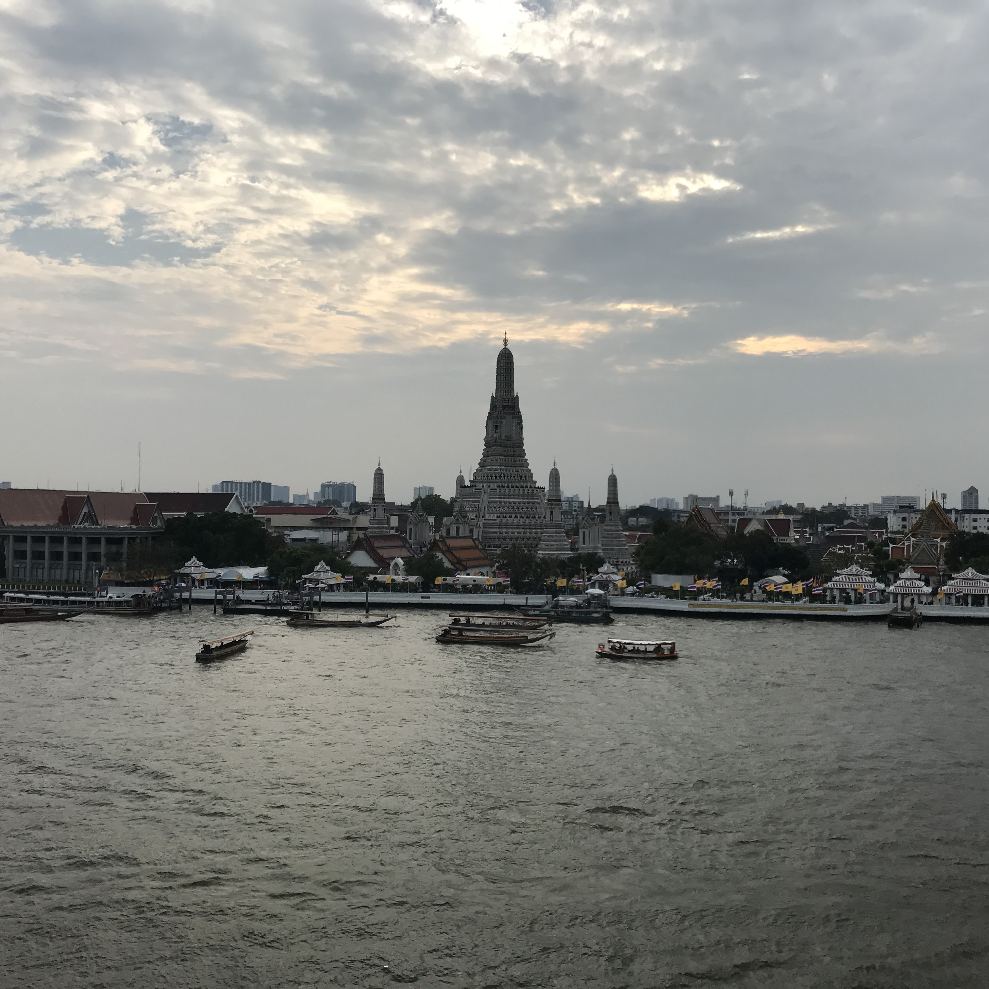

**Overnight in Bangkok**

|  |  |  |
| --- | --- | --- |
| Day3 | Kanchanaburi | (B,L,D) |

**Breakfast in hotel**

**Loud voice to silent voice**

The tour today will take you to **Talad Rom Hub.** Here you will have a chance to explore the local market while waiting for the scheduled train coming through the market, then you the merchants move up their stuff and the market turning into a live rail track. The next destination is **Damnoen Saduak Floating Market**, where you can explore the local market but this is very special because you will see the vendors selling on the wooden boats. Then you will take a short boat ride to enjoy the fascinating scenes and see the lifestyle along the canal of this province.

**Lunch** at the local restaurant

Then we will drive to Kanchanaburi. It’s one of the important country, where you can learn a lot of history through the real place. Firstly, you will visit the **War Cemetery**, where are now 5,085 Commonwealth casualties of the Second World War buried or commemorated in this cemetery. Then you will sum up the history of the war at the **Thailand-Burma Railway Centre**. It is an interactive museum, information and research facility dedicated to presenting the history of the Thailand-Burma Railway. This ran 415 km from Ban Pong in Thailand to Thanbuyuzayat in Burma, and was built by the Imperial Japanese Army during the second World War using Allied prisoners of war and impressed Asian labourers. After that, we will transfer you to Phutakien Pier to your hotel. You will enjoy your evening at the floating house with a **delicious** dinner.

**Overnight in Kanchanaburi**

|  |  |  |
| --- | --- | --- |
| Day4 | Kanchanaburi | (B,L,-) |

**Breakfast in hotel**

**Back to Basic**

Today we will go to **Hellfire pass**, section of rock that was dug out by Prisoners of War intended to allow the Death Railway’ to continue its route from Bangkok to Rangoon. The you will take short train ride on **the Death Railway**, the original wooden bridge, which was built by the prisoners of the War.

In the afternoon we will drive back to bangkok and will stop at **Phra Pathommachedi**, the tallest stupa in thailand. Not far from Phra Pathommachedi is **Sanam Chandra Palace**, which is set in a beautiful park full of giant trees and perfectly maincured lawns winding around ponds and lakes. At the end of the day, we will drive back to Bangkok.

**Overnight in Bangkok**

|  |  |  |
| --- | --- | --- |
| Day5 | Ayutthaya | (B,L,-) |

**Breakfast in hotel**

**Going where Siam started**

The tour today will take you to Ayutthaya. Firstly, visit **Bang Pa-In Summer Palace,** first used by the royal court as a summer retreat in the 17th century. The only royal residence open to the public is the Chiness-style Wehat Chamroon Palace, constructed entirely of materials imported from China.Afterwards visit **Wat Phanancherng,** which contains the oldest large cast bronze Buddha image in Ayutthaya and **Wat Yai Chai Mongkhon** built by King U-thong in 1357 A.D.

**Lunch** at the local restaurant

In the afternoon you will explore **Ayutthaya Historical Park,** There you visit **Wat Phra Mahathat,** a sacred temple where the relics of the Lord Buddha wereinstalled. The Prang of Wat Mahathat was built in Early Ayutthaya. Its structure became the traditional model when constructing a temple and can be found nationwide.

**Overnight in Bangkok**

|  |  |  |
| --- | --- | --- |
| Day6 | Sukhothai | (B,L,-) |

**Breakfast in hotel**

**Time in old ancient**

Today, we will fly from Bangkok to Sukhothai. Start your visit of **Sukhotai Historical Park.** Together with Kamphaeng Phet and Sri Satchanalai, Sukhotai constitutes a UNESCO World Heritage site.

In 1238, Sukhothai became the first truly independent Thai kingdom. Historical artifacts have shown that Thai culture originated in Sukhothai, in particular the Thai language and alphabet. You will start your visit at the **Ramkamhaeng Museum.** After this you visit the adjacent **Wat Mahathat** by foot.

You will visit **Wat Phra Phai Luang** **and Wat Si Chum** amongst others.

**Overnight in Sukhothai**

|  |  |  |
| --- | --- | --- |
| Day7 | Sukhothai | (B,L,-) |

**Breakfast in hotel**

**Discover the world heritage**

Departs to Sri Satchanalai. We follow a lovely rural road until we reach the ruins of **Sri Satchanalai.** Here we will visit **Wat Chedi Chet Thaew** and **Wat Chang Lom**, two of the most interesting sites. Next stop is **Celadon Kiln** Site Study and Conservation Centre which contains a display of kilns, artifacts and excavated ceramics. Si Satchanalai, or Sawankhalok, was an important producer of glazed ceramics called Sangkhalok wares which were exported throughout Asian countries.

After this we will drive to our final destination of today, Lampang. **Lunch** will be at local restaurant.

We will visit **Dhanabadee Ceramic Museum** and Factory where the famous “chicken bowl” is being produced. The dragon kiln is the oldest kiln in Lampang Province. You will get a guided tour and will see the production process of ceramics from upclose.

After this we will make a walking tour of **Talat Gao Street** with its many historic houses. Your guide will tell you the history of some of the beautiful houses. We will also have a look at the historic Rachadapisek Bridge.

**Overnight in Lampang**

|  |  |  |
| --- | --- | --- |
| Day8 | Lampang | (B,L,-) |

**Breakfast in hotel**

**Through Lanna Kingdom**

Today we will drive into town and make a one hour **horse cart** ride through the old streets of Lampang.

After this we will visit **Wat Pong Sanuk, Wat Phra Kaew Don Tao, Ban Sao Nak** and the former **house of Louis T.Leonowens**, the son of Anna Leonowens from the book “Anna and the King of Siam”.

Lunch will be at local restaurant.

Then, we will continue to **Wat Prathat Lampang Luang**, considered by many the most magnificent temple of Northern Thailand.

Drive to Chiang Mai, we will stop on the way at **Hairiphunchai Temple** in Lamphun. Drop off at the hotel later this afternoon.

**Overnight in Chiang Mai**

|  |  |  |
| --- | --- | --- |
| Day9 | Chiang Mai | (B,L,-) |

**Breakfast in hotel**

**Special time at the unique city**

You will be picked up at your hotel at 08.00 for your Chiang Mai Temples Day tour. You will visit some very famous but also some lesser known temples that are located within the Old City of Chiang Mai. First of all we will head off to **Wat Lam Chang**. This temple has a very old brick chedi. Next up is **Wat Chiang Man**. This is Chiang Mai's oldest temple. King Mengrai, the founder of Chiang Mai, built this temple in 1296. We leave through the backdoor and head for **Wat Phra Singh**. This is probably Chiang Mai's most revered temple. Wat Phra Singh currently houses Phra Chao Thong Tip, the most venerated Buddha statue in northern Thailand. From Wat Phra Sing we make our way to Wat Chedi Lunag with its giant chedi. An earthquake in 1545 damaged the chedi. Next to Wat Chedi Luang is Wat Phantao which is a beautiful wooden temple.

**Lunch** will be at a local restaurant. After lunch we will visit Wat Suan Dok, one of the most important temples in Chiang Mai. Within the temple compound are a white mausoleums, which house the cremation ashes of members of the royal family of Chiang Mai.

After the city tour is the **Cooking Class** at Sala Lanna. You will have a chance to learn how to cook Thai dish. You can also choose 4 different kind of dishes such as Thai famous food or Thai traditional northern food. You will learn from the beginning of the process and how to prepare the ingredients. Moreover, you also have to go to the market and buy the ingredients by yourself. After finish the cooking class you can enjoy your dish at On the Ping Riverfront restaurant.

**Overnight in Chiang Mai**

|  |  |  |
| --- | --- | --- |
| Day10 | Chiang Mai | (B,L,-) |

**Breakfast in hotel**

**Sharing is caring**

This morning departs from hotel to **Thai Elephant Care Center** which is the last home for elderly elephants. Upon arrival, you will meet and brief about Asian Elephant and Safety before changing the uniform. After that, you will visit and interact with elderly elephants. Following by learning to make grinded grass for elephant and feed them. Continue to elephant cemetery and area of resting in the nighttime. Learn how to make herb balls for elephant. After that, prepare to bath with elephant. Then, feed elderly elephant with basket of banana.

Lunch will be at local restaurant. After lunch visit **Elephant Poo Poo Paper Park** is an eco-friendly, naturally built, outdoor museum park that introduces and explains the unique steps involved in making our much talked about paper products from elephant poop fibers! Your guide will explain about the plight of the Asian elephant.

**Overnight in Chiang Mai**

|  |  |  |
| --- | --- | --- |
| Day11 | Lampang | (B,L,D) |

**Breakfast in hotel**

**Top on the top**

Depart to Wat Chaleom Phra Kiatvia Lampang, we will first visit **Chaeson National Park**. This national park is a lush forested and mountainous region. The main attraction is the hot spring with a 73 degree Celsius water spring over rocky terrain. The heat from the hot spring providing a misty and picturesque scene which is particular beautiful in the morning. Only one kilometer away is **Chae Son Waterfall** which is the 6-level waterfall with clear water flowing through high mountains.

**Lunch** will be at local restaurant.

Continue to **Wat Chaloem Phra Kiat Phrachomklao Rachanusorn** which is perched high on top a rocky hill in Lampang's countryside, nearly 1,000 metres above sea level, offering you a truly unique Buddhist shrine and temple visiting experience. Apart from the temple's location being the pinnacle of its emerging fame, here you'll get a spectacular and panoramic view of the **Thung Thung valley** below. A visit to the top of the temple required a hike about 800 meter up stair.

Upon arrival at the top, you will have time to relax and enjoy the panorama view before drive back to Chiang Mai. The drive takes about 3 hours.

Transfer to the hotel for fresh up before enjoy with **Khantoke dinner** and traditional performance.

**Overnight in Chiang Mai**

|  |  |  |
| --- | --- | --- |
| Day12 | Chiang Rai | (B,L,-) |

**Breakfast in hotel**

**Wonder in Chiang Rai**

We will drive to Chiang Rai, on the way stop to visit **Hot spring at Mae Kha Chan**. Continue to Wat Rong Khun, **the white temple**. You might have the chance to meet the artist behind the project (who also did mural paintings at the Buddha Prateep Temple in London). Lunch will be at local restaurant.

After that, visit Ban Dam aka the “**Black House”.**

It is the proud work of Thawan Duchanee, a Thai artist who has developed a style of work representing the darkness in humanity. With lots of red and black hues, skins, skulls and various other animal parts made into eerie artwork. After that we will stop at **Wat Rong Seua Ten** or it’s also called blue temple bevor we drive to Chiang Rai

**Overnight in Chiang Rai**

|  |  |  |
| --- | --- | --- |
| Day13 | Chiang Khong | (B,L,-) |

**Breakfast in hotel**

**Lost in Chiang Rai**

Depart from hotel and drive up to visit the **Doi Tung Development project**, Mae Fah Luang Garden, Doi Tung Royal Villa, the Princess Mother commemorative hall. Continue to **Chiang Saen**, reach the border triangle Of Myanmar, Laos and Thailand, better known as the **Golden Triangle**. Make a **short boat** tour with a stop on the Laotian river Island Don Sao. Then drive to visit **Hall of Opium** explains the journey through the long history of Opium, the ancient origin and the how’s and why’s it spread globally – with its influences. Transfer back to your hotel in Chiang Khong.

**Overnight in Chiang Rai**

|  |
| --- |
| End of Service |